DRM ASSIGNMENT  
GROUP-25



**___**

By: SAHIL VARMAN-2019B1A31017H

**TANMAY BHETHANABHOTLA-2020B3A71815H**

CHRIS ALEX MATTAM- 2020A4PS2319H

B.ADITYA SRIVARDHAN - 2020B2A42410H

**G.Raja Bhaskar Reddy-2020A4PS2245H**

# 

# 

# INTRODUCTION

ITC Limited is an Indian conglomerate company headquartered in Kolkata. Established in 1910, ITC is the largest cigarette manufacturer and seller in the country. ITC operates in five business segments at present — FMCG Cigarettes, FMCG Others, Hotels, Paperboards, Paper and Packaging, and Agri-Business

## FUNDAMENTAL ANALYSIS

### EPS (Earnings Per Share)

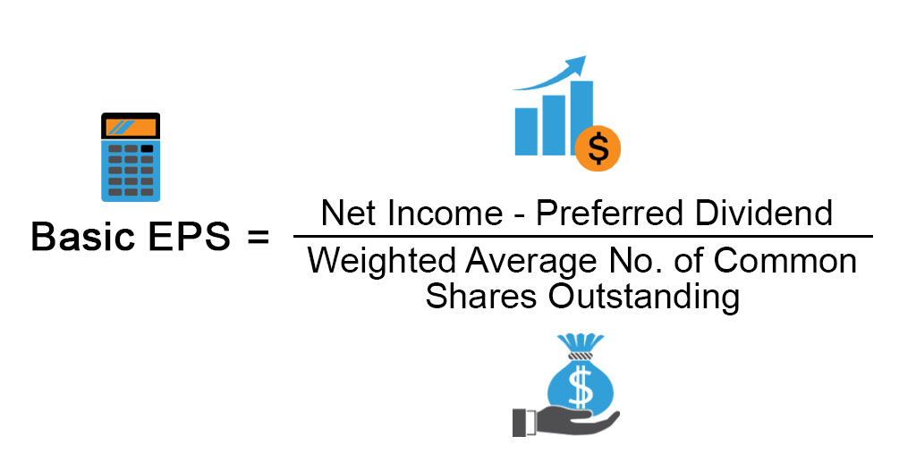

Earnings per share (EPS) is a company's net profit divided by the number of common shares it has outstanding. It indicates how much money a company makes for each share of its stock and is a widely used metric for estimating corporate value.

A higher EPS indicates greater value because investors will pay more for a company's shares if they think the company has higher profits relative to its share price. EPS can be arrived at in several forms, such as excluding extraordinary items or discontinued operations, or on a diluted basis.

### PE ratio ( Price to Earnings Ratio)

The price-to-earnings ratio (P/E ratio) is the ratio for valuing a company that measures its current share price relative to its earnings per share (EPS). The price-to-earnings ratio is also sometimes known as the price multiple or the earnings multiple.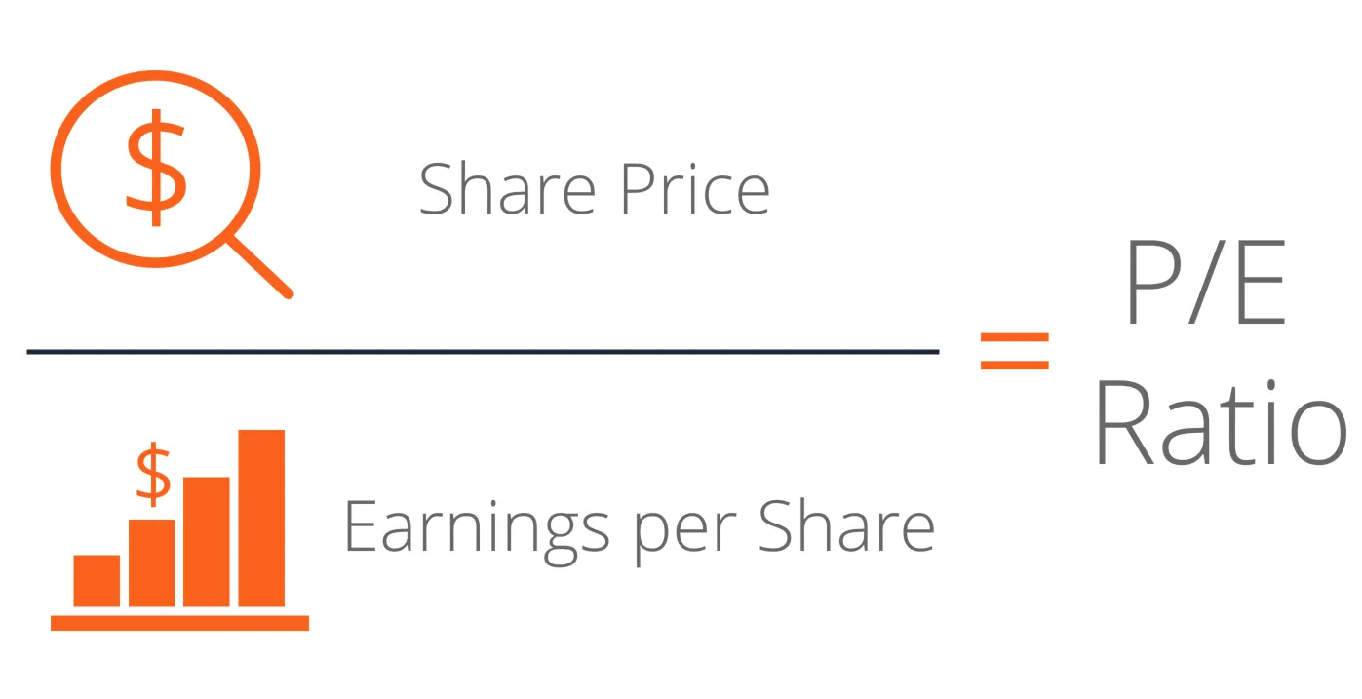

A high P/E ratio could mean that a company's stock is overvalued, or else that investors are expecting high growth rates in the future.

Companies that have no earnings or that are losing money do not have a P/E ratio because there is nothing to put in the denominator.

Two kinds of P/E ratios—forward and trailing P/E—are used in practice.

### ROE ( Return on Equity)

### Return on equity (ROE) is a measure of financial performance calculated by dividing net income by shareholders' equity. Because shareholders' equity is equal to a company’s assets minus its debt, ROE is considered the return on net assets.

### 

### ROE is considered a gauge of a corporation's profitability and how efficient it is in generating profits. ROEs differ from sector to sector.

## TECHNICAL ANALYSIS

### MACD

The Moving Average Convergence/Divergence indicator is a momentum oscillator primarily used to trade trends.

Moving average convergence divergence (MACD) is calculated by subtracting the 26-period exponential moving average (EMA) from the 12-period EMA.

**How does this indicator work?**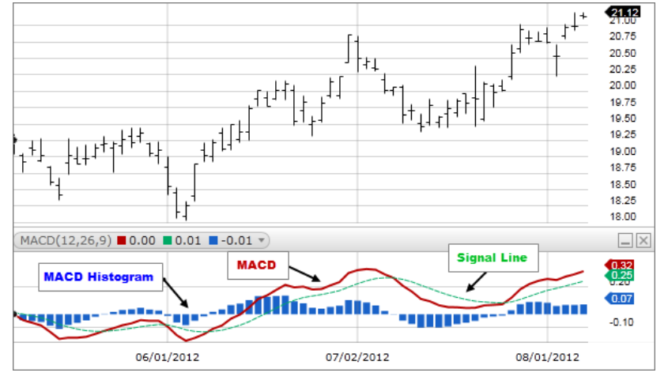

MACD crossing above zero is considered bullish while crossing below zero is bearish. Secondly, when MACD turns up from below zero it is considered bullish. When it turns down from above zero it is considered bearish. When the MACD line crosses from below to above the signal line, the indicator is considered bullish. The further below the zero line the stronger the signal.

When the MACD line crosses from above to below the signal line, the indicator is considered bearish. The further above the zero line the stronger the signal.

### Bollinger Bands

A Bollinger Band is a technical analysis tool defined by a set of trendlines plotted two standard deviations (positively and negatively) away from a simple moving average (SMA) of a security's price, but which can be adjusted to user preferences.

Bollinger Bands are envelopes plotted at a standard deviation level above and below a simple moving average of the price. Because the distance of the bands is based on standard deviation, they adjust to volatility swings in the underlying price.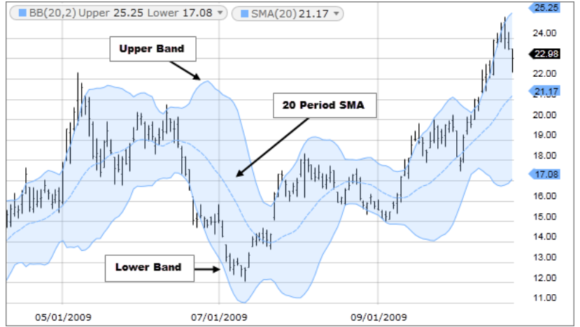

There are three lines that compose Bollinger Bands: A simple moving average (middle band) and an upper and lower band. The upper and lower bands are typically 2 standard deviations +/- from a 20-day simple moving average, but they can be modified.

**How does this indicator work?**

When the bands tighten during a period of low volatility, it raises the likelihood of a sharp price move in either direction. When the bands are separated by an unusually large amount, volatility increases, and any existing trend may be ending.

A moving average (MA) is a widely used technical indicator that smooths out price trends by filtering out the noise from random short-term price fluctuations. Moving averages can be constructed in several different ways and employ different numbers of days for the averaging interval. The most common applications of moving averages are to identify trend direction and to determine support and resistance levels. When asset prices cross over their moving averages, it may generate a trading signal for technical traders.

### RSI (Relative Strength Index )

The relative strength index (RSI) is a momentum indicator used in technical analysis that measures the magnitude of recent price changes to evaluate overbought or oversold conditions in the price of a stock or other asset. RSI fluctuates between 0 and 100%.

An asset is usually considered overbought when the RSI is above 70% and oversold when it is below 30%.

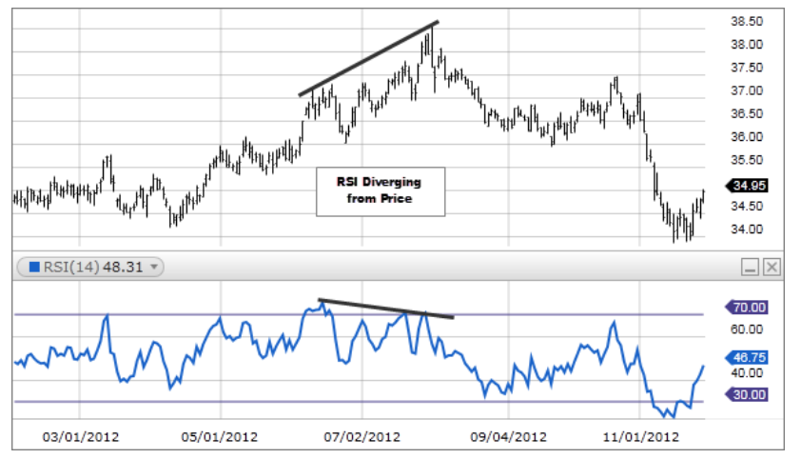

### Simple Moving Average

An SMA is calculated by adding all the data for a specific time period and dividing the total by the number of days.

**How does this indicator work?**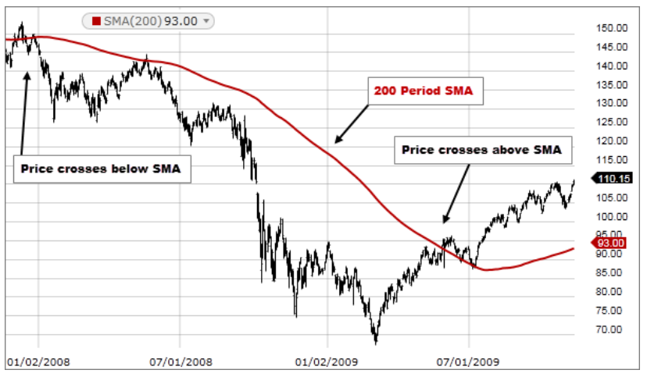

SMAs are often used to determine trend direction. If the SMA is moving up, the trend is up. If the SMA is moving down, the trend is down. A 200-bar SMA is a common proxy for the long-term trend. 50-bar SMAs are typically used to gauge the intermediate trend. Shorter period SMAs can be used to determine shorter-term trends.

SMAs are commonly used to smooth price data and technical indicators. The longer the period of the SMA, the smoother the result, but the more lag that is introduced between the SMA and the source.

Price crossing SMA is often used to trigger trading signals. When prices cross above the SMA, you might want to go long or cover short; when they cross below the SMA, you might want to go short or exit long.

SMA Crossing SMA is another common trading signal. When a short period SMA crosses above a long period SMA, you may want to go long. You may want to go short when the short-term SMA crosses back below the long-term SMA.

## 

## STOCK PRICE PREDICTIONS:

## Technicals are strongly bullish. Fundamentals will be more assertive in dominance in the long run. Thus the stock price can be expected to have a bullish run.

## Using the Technical analysis; of the MACD line we can clearly see that the MACD line is intersecting the signal line and we can wait for 2-3 days for confirmation. If it continues to cross over it will be a very good opportunity to go long in the stock. The weekly MACD is also similar;y showing a bullish trend.

**A high EPS indicates that the company’s profitability is increasing and it has generated more wealth which it can distribute among its shareholders.** 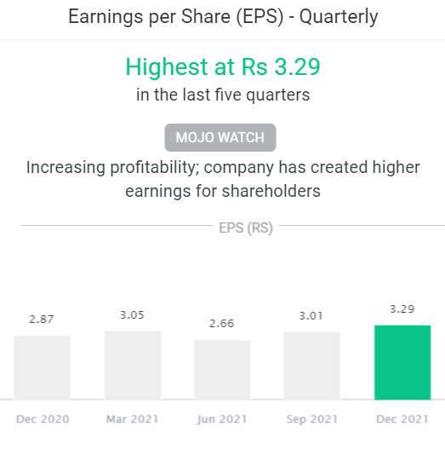

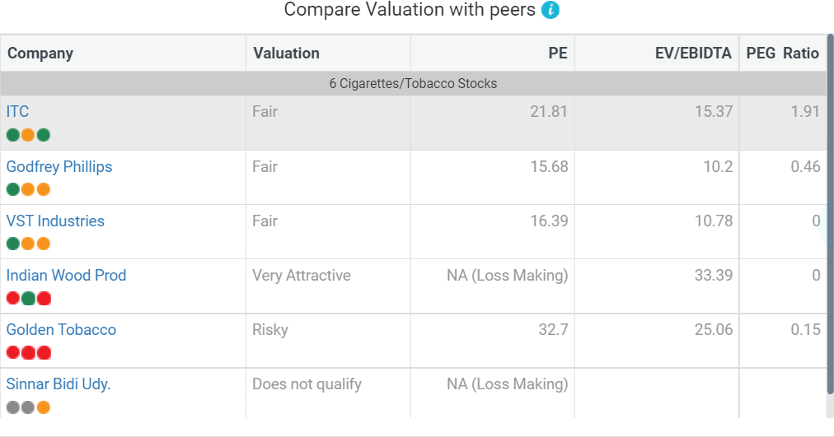PE ratio is relatively higher as compared to its peers (cigarette companies). Only golden tobacco has a higher PE. This shows a strong P.E. ratio and a positive growth sentiment is there in the market.

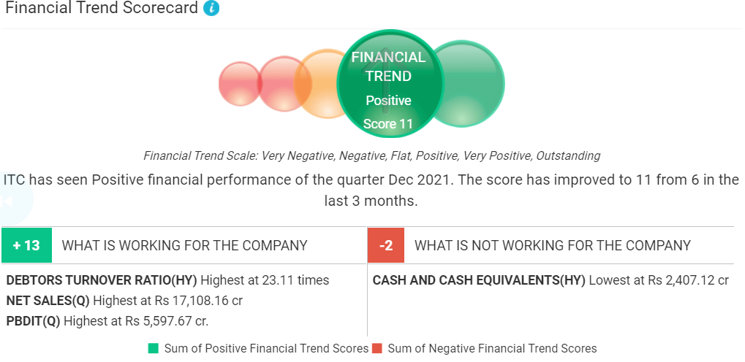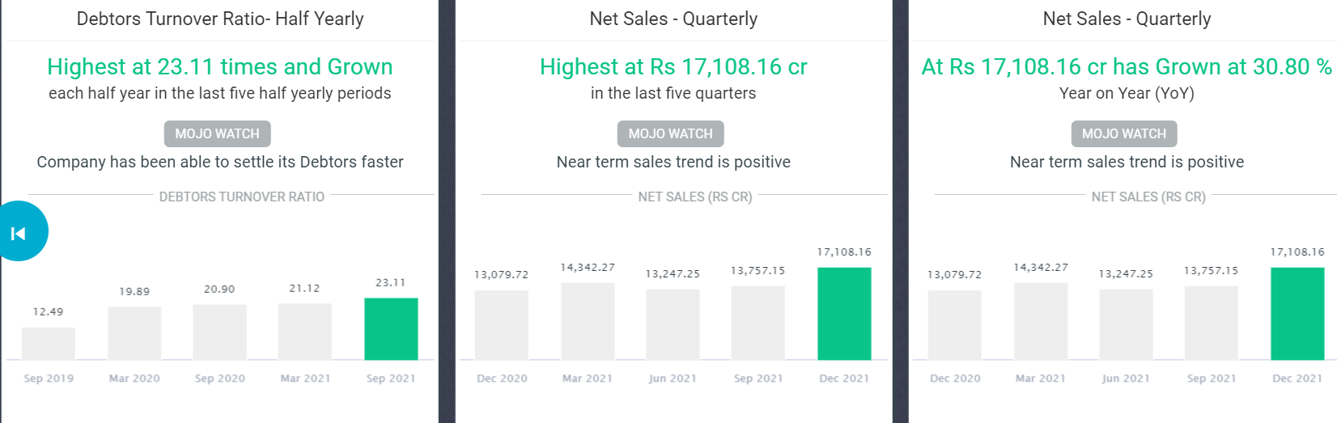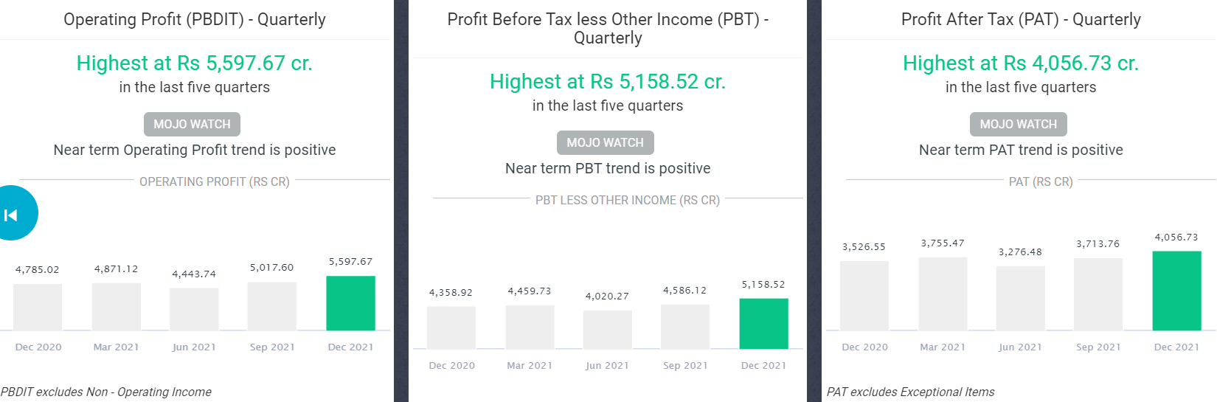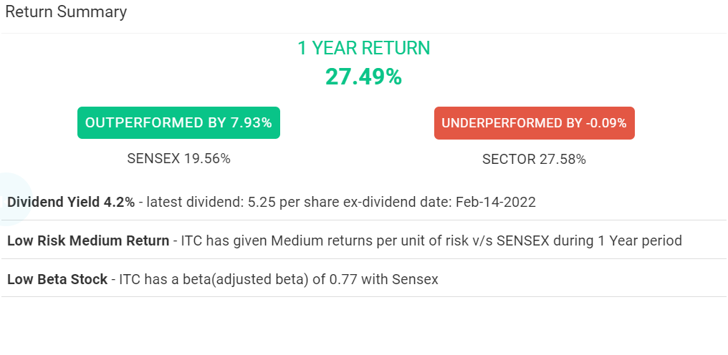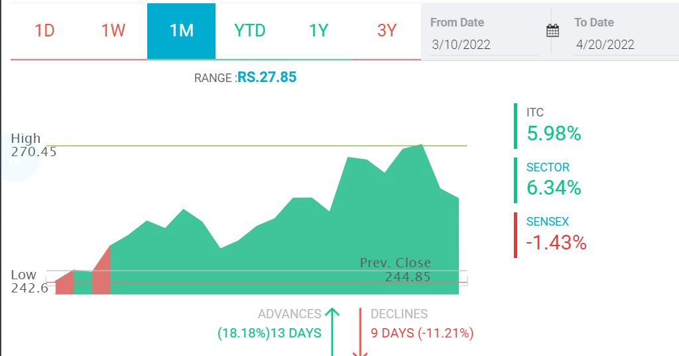

### 

### 

### OPTION TRADING STRATEGY

**Near month (May 2022): As RSI is giving no signal, we can assume that the ITC Stock is range-bound, if not moderately bullish. The stock of ITC is trading in the range for a long period. To take advantage of this range-bound movement, traders can apply a Short straddle strategy. The stock has been trading in the range of Rs 200 to Rs 227 for the last six months. One may use these levels as a stop loss. The share prices have been falling shortly. An initial buy or sell signal has not been generated yet. However, if a BUY/SELL signal is mentioned below then you can choose to take a trade with a strict stoploss.**

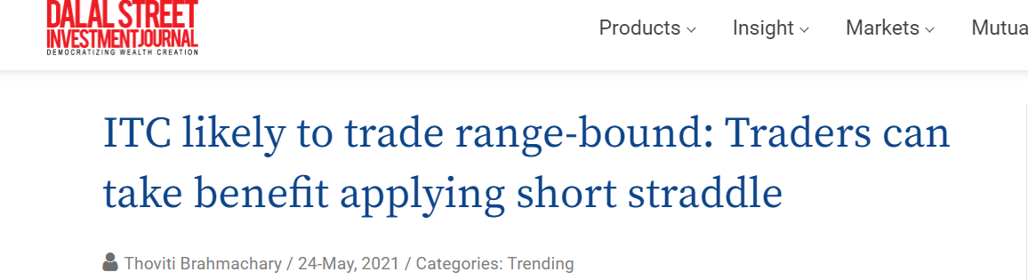

**Due to multiple DOJIs in the long term, we can strictly see that neither the bears nor the bulls are able to drive the price down or up and have any significant control over the market. Conservative range-bound strategies thus look attractive to invest in.**

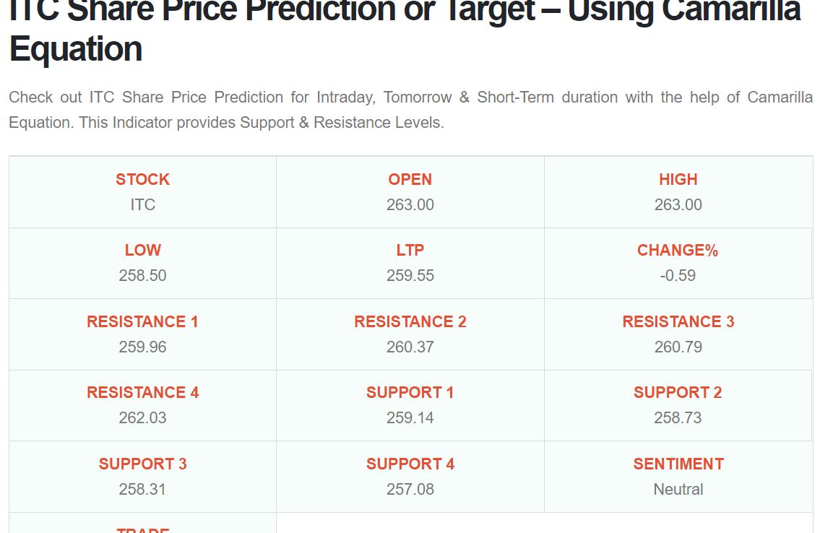

**VERDICT: RANGE-BOUND**

**Next month (June 2022): We can use bullish options strategies as we are observing a steady bullish trend for the stock in the expected analysis of the next month. So here is the strategy. ITC fast MACD line is below the slow signal MACD line, and in the golden cross-zone, positive zone.**

**Both the lines are converging, coming close to each other with a difference of 1.96**

**A strong BUY signal might be generated soon. Keep a close watch. Bookmark this page & recheck tomorrow**

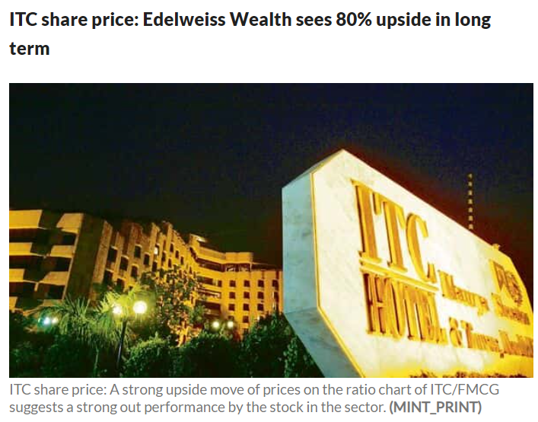

**SELL ITC 210CE JUNE2021 at Rs.6.75 and SELL ITC 210PE JUNE 2021 at Rs 8.70. The Upper Breakeven point would be Rs.225.45 and the Lower Breakeven point would be Rs. 194.55.**

**If a trader initiates a short straddle, he would receive net credit of approx. Rs 49,440. Maximum profit would be received if stock closes at Rs 210 on the expiry day, however, the stock is likely to incur losses if it starts to move below or above the breakeven point. Estimated loss at the breakeven point would be Rs 3200.**

**ITC share price has given sharp upside bounce in year-to-date (YTD) time that indicates bulls' attraction towards the Indian conglomerate company's shares. After tepid 12 per cent return in last one year, Edelweiss Wealth is highly bullish on ITC shares. The Edelweiss Wealth research says that there is strong possibility of trend reversal and the stock may go up to ₹450 apiece levels in long term. ITC share price today is ₹249.95 per share levels on NSE.**

**Speaking on the reason for being bullish on** [**ITC shares**](https://www.livemint.com/market/stock-market-news/day-trading-guide-for-wednesday-7-stocks-to-buy-or-sell-today-23rd-march-11647995917089.html)**; Edelweiss Wealth research report said, "A strong upside move of prices on the ratio chart of ITC/FMCG suggests a strong out-performance by the stock in the sector. Prices on the ratio chart suggest a base formation hinting towards the start of a strong out-performance by the stock. A probable formation of an inverted head and shoulder pattern on the weekly charts and a time series analysis on the quarterly chart indicate a change in trend and resurgence of the super bull cycle." The report went on to add that ratio chart on a P&F platform indicates a strong base building formation underway since two years.**

**Expecting fresh breakout in ITC share price in coming session; Edelweiss Wealth report said, "ITC is on the cusp of a breakout from an inverted head and shoulder pattern (strong trend reversal), which shall be validated on a weekly close above ₹253. Price action on the long-term chart (quarterly) shows every time the stock corrects or consolidates for 14–16 quarters, a fresh uptrend resumes. ITC has been in consolidation since the last 15 quarters, with the current quarter being the 16th one. A quarterly close above ₹253 implies the highest closing the stock will record in two years."**

**On fundamentals that may fuel ITC share price rally; the wealth research report said, "We expect the volume in cigarettes to revive at a CAGR of 5 per cent during FY22–24E as against a CAGR of -1 per cent during FY11–21; FMCG’s EBITDA margin to scale up to higher single digits; and the hotel, paperboard and agri-commodities businesses to revive. This will lead to an earnings CAGR of 12 per cent in FY22–24E against a mere 7 per cent in the last five years."**

**On its suggestion to positional investors in regard to ITC shares, Edelweiss Wealth research report has recommended stock market investors to buy ITC shares at current levels for long term target of ₹450 maintaining stop loss at ₹220 apiece levels.**

**VERDICT: Bullish**

**Far month (July 2022): As we expect a bullish trend in stock prices we can opt for bullish option trading strategies. The support and resistance levels of ITC are derived based on an analysis of the entire year's daily closing prices. These are all extremely strong levels to watch in Itc.**

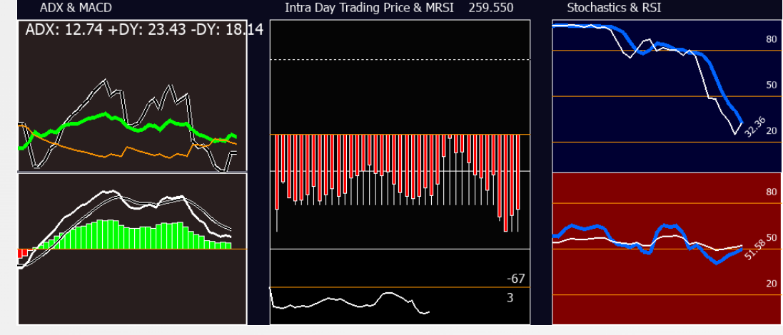

**Levels to watch:**

**ITC has strong support or resistance at 203, 214, 225, 237, 251, 269**

**The current share price is 259.55**

**VERDICT: Moderately Bullish**

**THANK YOU**

**xxx—---------xxx**